Chandler Oak mural survey

- Would you prefer to see this mural restored (repainted exactly the same) or refreshed with a contemporary feel (see image below) ^{Required}
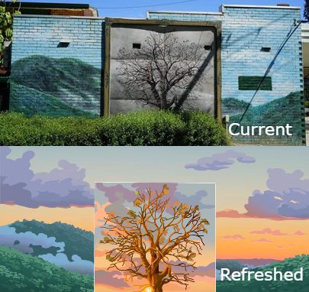
Select one answer only

Restored
Refreshed
- Would you like to provide any other comments?

Privacy Statement
We handle any personal information you provide in this form in accordance with the Privacy and Data Protection Act 2014. For more information, see our Privacy Policy.

