Asset Plan Community Panel Report
May 2025

Introduction
This report outlines the process and presents the outputs from the Knox City Council Asset Plan Community Panel deliberative engagement process conducted in April and May 2025.
The Knox community is growing, and Council needs to deliver a wide range of services to meet the diverse needs of the community. Assets are core to delivering these services.
Building on the work already completed to define priorities and services as part of the development of the Council Plan, health and Wellbeing Plan and Financial Plan, Council needs to ensure they have balanced the potential financial investment into assets with long term financial sustainability.
Knox continues to invest in community facilities and assets. But with a limited budget, rising costs, forecast population increase by 13% (Forecast 2035 is 174,125) and more extreme weather events, they need to prioritise.
Given Council’s current financial challenges and diverse needs of the community, a Panel of community members were asked to consider how they understand their asset priorities, their performance and what Council needs to consider when making decisions on discretionary funding. This report summarises the feedback of the Panel and their discussions.
The report has been prepared by CTM Group who were engaged to facilitate the deliberative process. The report presents the outputs from the two sessions and online workbook as a summary of the feedback from the community.
The report from the Community Panel will inform the development of Council’s 10-year Asset Plan and be considered by Council when making decisions on long term asset management.
The Deliberative Panel
The Local Government Act requires Council to use deliberative processes when engaging the community on the development of the Asset Plan. This gives participants the opportunity to collaborate closely with Council, to understand the dilemmas we are facing when balancing the identified community priorities and long-term financial sustainability.
In March 2025, Council invited residents of Knox to submit an expression of interest to be a part of the Knox Asset Plan Community Panel (The Panel). Over 80 people nominated, with 25 members selected to align with the demographic profile of Knox. This process was completed using de-identified information by an independent organisation.

Summary of demographic profile of the Panel:
- Gender: 12 Men, 12 Women, 1 non-binary
- Age: all targets met, noting slightly under for ages 50-59 and no EOI received from anyone aged over 85
- Suburb: all suburbs represented and target met, noting Boronia slightly under target
- Language: 12 panellists spoke a language other than English at home
The full demographic profile listing targets and selected panel profile is available on haveyoursay.knox.vic.gov.au/asset-plan.
The full profile also includes household structure, connection to Knox and previous participation in consultation.
Session 1 was attended by 21 participants and session 2 was attended by 20 participants.

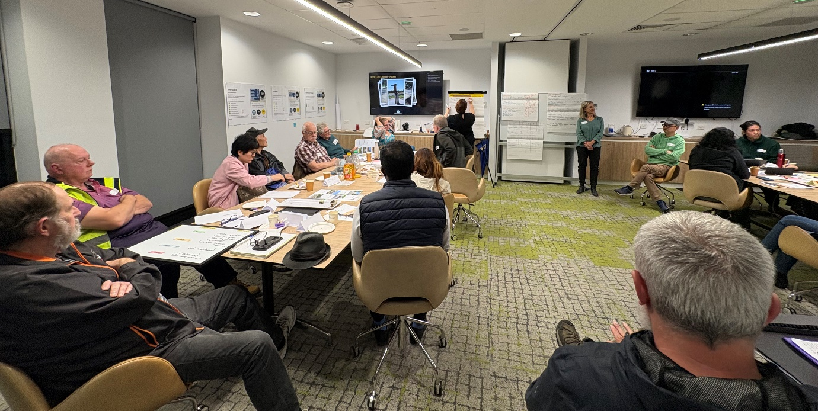

Remit
The remit is the question or statement that sets the scope for the Panel. This is the remit set by Knox City Council for the Panel to consider:
Like many Councils, we’re facing financial challenges and constraints. While we continue to invest in community facilities and assets, we need to prioritise and make hard decisions about our services to overcome a forecast funding gap.
Which assets should we prioritise improving to maximise positive outcomes for our community?
How should we spend wisely on our assets and facilities in the future?

Agenda and activities
The Panel met in two sessions at Knox Operations Centre in Knoxfield.
Session 1 – Wednesday 16 April 2025 – 6.00pm–8.00pm
Session 2 – Wednesday 16 April 2025 – 6.00pm-8.00pm
Over two sessions, the Panel worked through an empowering deliberative engagement process. This process involved learning about asset planning, thinking about challenges and considerations, and deliberating on the four asset classes in response to the remit. The asset classes: Transport, Stormwater and Drainage, Open Spaces, and Buildings were the high-level focus of the facilitated engagement approach.
Session 1 focused on setting the scene for the remit through a presentation, access to subject matter experts, asset class condition report posters, a workbook and a map of Knox.
Between session, the Panel members had access to Council’s Deliberative Engagement portal to respond to key themed questions to further enhancer thinking and learning about assets and the services they deliver.
Session 2 focused on learning from each other while deliberating, making choices in a group and identifying what are the priorities for Council consideration in each focus area.
In session 2, the Panel worked together to provide a collective response to the following themes:
- Opportunities and Challenges
- Key priorities for the next 10 years
- What things Council needs to consider

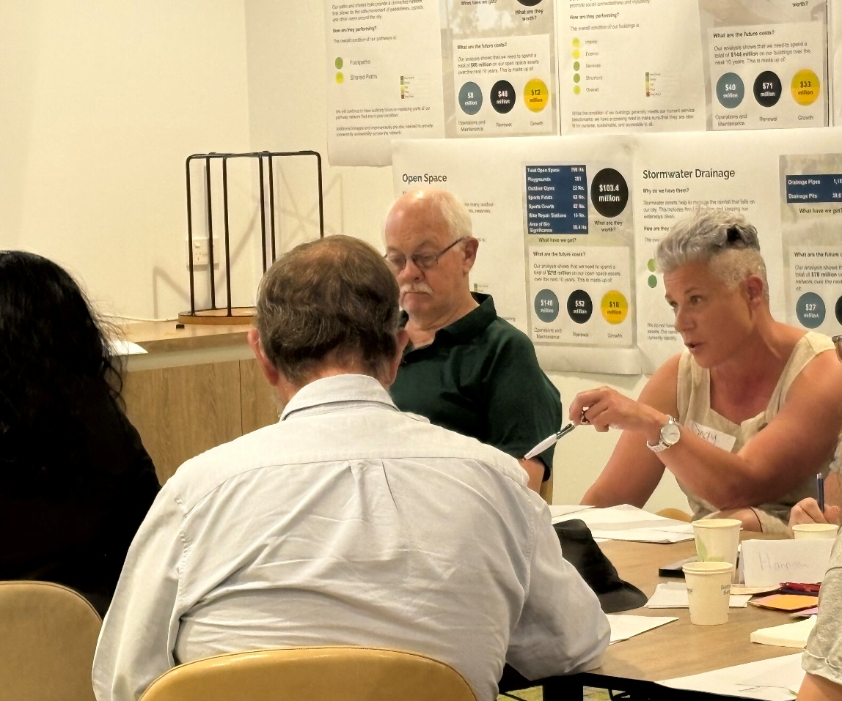
Feedback from the Panel
Opportunities and Challenges
The Panel, in four groups of five, were asked to respond to the questions ‘What big challenges and what big opportunities are Council facing over the next 10 years?’.

Challenges
The groups discussed their views and created a list of responses. They were then asked to prioritise their top three responses which were then captured on butchers paper as listed in the table below.
Group 1 | Group 2 | Group 3 | Group 4
Council concentrating on core responsibilities | Climate change impact on assets | Climate change | Deteriorating assets & quick fixes
Community Safety | Aging assets impact on budget | Finances – cost of living & Council’s constrained funding | Schools fenced, lack of access to recreation facilities
Impact of population growth | Population density increasing leading to demographic changes | overpopulation

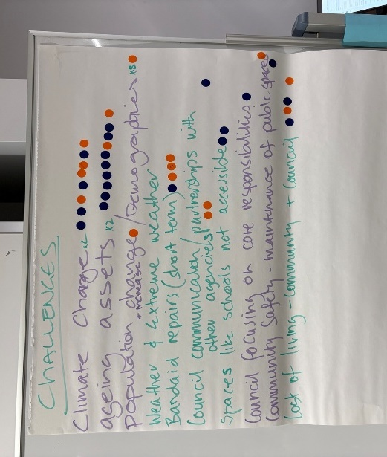
A consistent theme raised by the Panel was the impact of population growth and climate change on community assets. The discussion focussed on how growth will lead to housing density and the subsequent impact on buildings, roads/paths, stormwater drains and open spaces, ultimately impacting Council’s budget. The Panel discussed how these impacts will increase the funding gap as demand for services increases and more frequent asset maintenance due to weathering and higher usage rates deteriorate assets, and potentially shorten time-frames for renewals.
From the consolidated list, the groups deliberated further on what they believed were Council’s top two challenges. The Panel were asked to show their two preferences by adding a blue dot for their first choice and an orange dot for their second choice on the consolidated list.
Outcome
This activity highlighted what the Panel believe are the top two challenges facing Council over the next 10 years:
1. Aging Assets
2. Climate Change
Opportunities
The groups identified a range of opportunities and prioritised their top three preferences which was captured on butchers paper to create a consolidated list as detailed below.
Group 1 | Group 2 | Group 3 | Group 4
Divest underutilised assets | Research | Improve local spaces | Third spaces*
Increase technology | Sustainable solutions – materials & technologies | Diversity of opportunities | Communication & coordination with other Councils
Community events | Involve & consult with diverse community | Libraries expansion | Dog parks & bird proof bins

What we heard from the discussion, was the need to adopt new technologies to improve efficiencies in data collection to inform decision making. Also, the importance of community spaces that are passive, inclusive and informal which offer community connectedness and a sense of belonging.
Consultation with diverse communities to better understand and respond to service needs. Also, collaboration with neighbouring Councils to benchmark performance and seek opportunity, highlighted the importance of communications, information and stakeholder relationships.
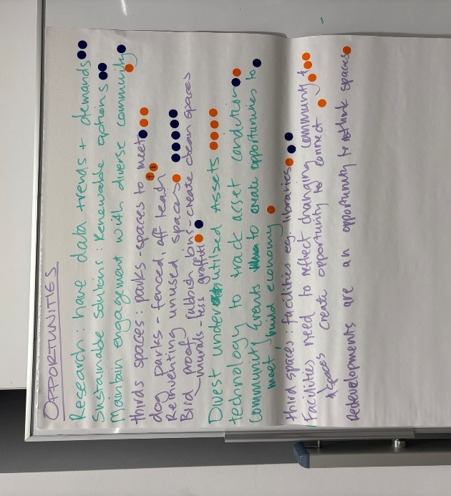
Outcome
This activity highlighted what the Panel believe are the top two opportunities for Council over the next 10 years:
1. Reinventing unused spaces /third spaces*
2. Research on assets – data trends and demands / sustainable renewable options
* Third spaces - Inclusive and accessible community spaces for reconnection, renewal and relaxation to provide a sense of social connectedness and belonging.

Key themes and priorities for next 10 years
The panellists responded to key themed questions in a workbook activity. Knox City Council hosted the workbook on their online engagement portal. Some panellist chose to complete the workbook in hard copy. The analysis of workbook feedback was grouped into six themes. We found the following key themes a priority for Council consideration:
Climate Ready - Building community resilience to climate change.
Social connections - Providing inclusive and accessible community third spaces for reconnection, renewal and relaxation to provide a sense of social connectedness and belonging.
Enhancing information and data driven decisions – Utilise technology and data analysis to inform our thinking and decision-making processes.
Optimising the asset base – Consolidation of underutilised buildings to achieve efficiencies and activating underutilised sport and recreation facilities and other green spaces.
Retain and enhance green spaces – Preserving habitat and increasing tree canopy.
Accessible transport connections – Providing shared paths to connect neighbourhoods to parks, buildings, public transport, and shopping centres.

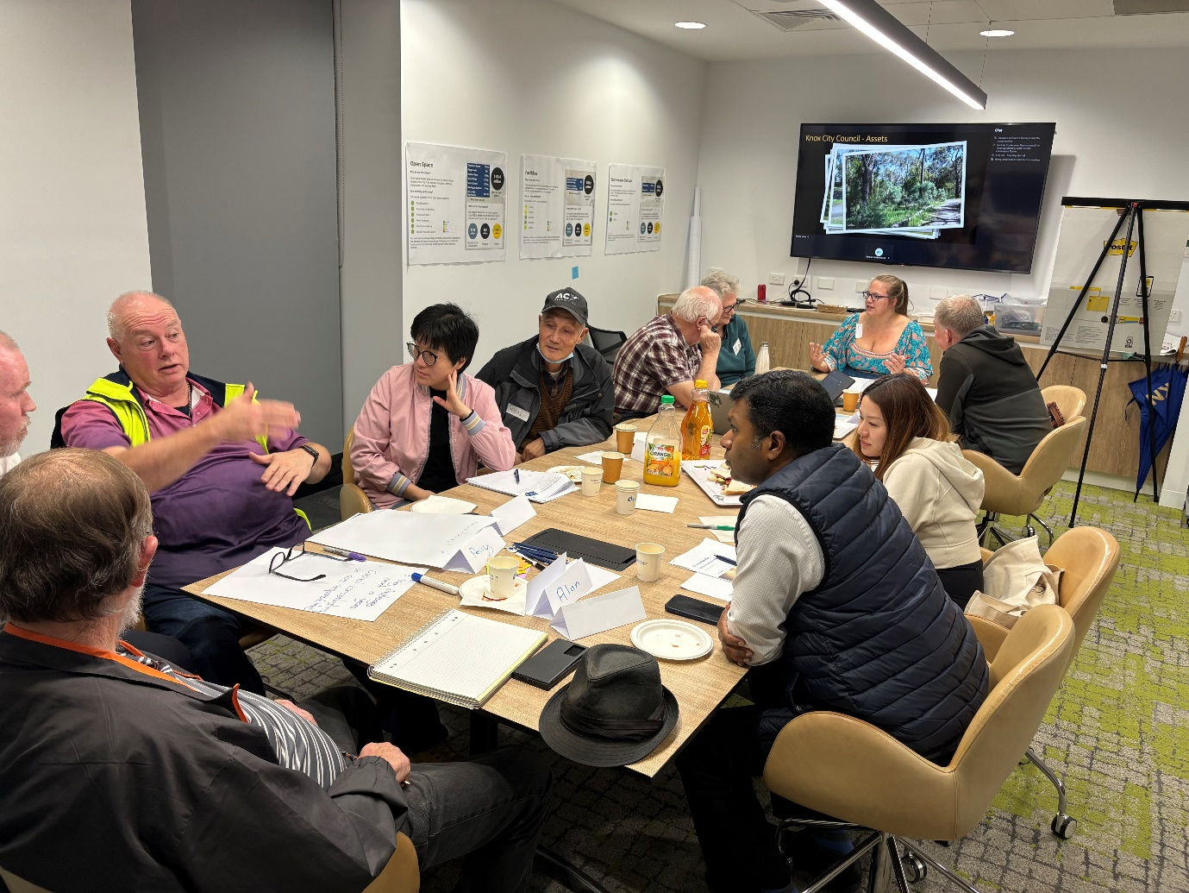

Asset importance and performance
Asset importance – The Panel was divided into four groups of five. They were asked to rank the four asset categories: Transport, Stormwater, Open Spaces and Buildings, in order of importance. The rankings for each facility were tallied to provide an overall score – the lower the score the more important.
Each group chose a different asset class for their most important asset.
With the tallied scores, transport scored as most important.
Consideration – When considering the whole community all assets are equally important.
Rank | Score | Asset class | Comments
1 | 8 | Transport | Relevant to everyone – drive or walk  Safety is of high importance and the risks are significant  Have to be able to get around (get to buildings)  Understand other responsible agencies  Council should prioritise key networks  Active transport also benefits health
2 | 10 | Open spaces | Open spaces are what make Knox great and have to be maintained  “we like them”  They promote community sharing and bring people together, spaces for people’s wellbeing  Help reduce the impacts of climate change
3 | 10 | Stormwater & Drainage | Mixed experience/expectation of flooding among participants  No one wants to be flooded and flood risk impacts insurance  Flood impacts other assets and increases costs  Opportunity – reduce impervious surfaces
4 | 12 | Buildings | Provide important opportunities for community connection  Maintenance will increase lifespan  Replace like for like, make them multipurpose and adaptable  Should be adaptable to changing demographics  Consider opportunities for partnerships for funding

Asset performance – The Panellists undertook a similar activity to rank each asset class on their level of service performance.
The table below shows the Panellist scorings for performance, and supporting commentary on what things Council is doing well and where Council can do better. Note the lower the score the higher the ranking.

Rank | Score | Asset class | What Council is doing well | Where Council can do better
1 | 5.5 | Buildings | Overall feeling pretty good.  Libraries | Increase usage of buildings by a broader representation of the community or consider divestment where suitable.  Consider ways to gain and / or increase income from buildings.  Maintenance, especially toilets kept to a standard.  Delays in repairs.
2 | 9 | Transport | Locals well looked after.  Meets expectation.  Pathways connecting hubs. | Potholes.  VicRoads lack of maintenance.  Fix critical road repairs first.
3 | 11.5 | Open spaces | Top quality assets | Bird proof bins.  Dog poo and better waste disposal provision.  Loss of Basketball (Boronia).  Maintain grasses to bring wildlife. Reduce habitat fragmentation.  Preserve & protect biodiversity & tree canopy.
4 | 14 | Stormwater & Drainage | Raingardens | Mitigate flooding (Rowville).  Impact of residential leaf blowers/litter – block drains.  Increase retarding basins.

Consideration - Panel discussion highlighted the need to use new technologies to capture data on asset usage rate and performance monitoring to make wise and well evidenced decisions.
Consideration – Performance criteria and evidence-based reporting is important when making financial decisions.

Further findings for Council to consider
- Data driven decision making
- Future proofing buildings, road surfaces and stormwater drain
- Ensure assets are maintained and available
- Repurpose under-used facilities
- Collaboration with neighbouring Councils
- Communication with diverse groups
- Prioritise accessibility and inclusivity

“It doesn’t matter which asset category, but it needs to be maintained, where possible utilise technology to build efficiencies, safe, accessible, lean towards trending demographics, able to flex to trends, minimal maintenance needs, smarter monitoring of assets and resilient to impacts of climate change.”
Panel participant

Limitations
The community panel represented the services needs of a diverse population which is growing rapidly. The panel should be commended on their efforts to learn about asset planning and participate in a deliberative approach. With population growth comes a change in demographics, trends and priorities. A lot can happen in four years, let alone ten years. There are limitations in predictability in the longer term. Further consultation and monitoring of assets and their service level performance are vital to stay attuned to impacts and changing trends.

Finally
The Asset Plan Community Panellists showed their commitment the deliberative engagement through high attendance rates and the level of involvement in discussion and activities. Positive feedback has been received on the process. There is an appetite for more involvement and deeper conversations in the future. Further community involvement would assist Council with keeping pace with emergency needs, changing trends and population growth.

