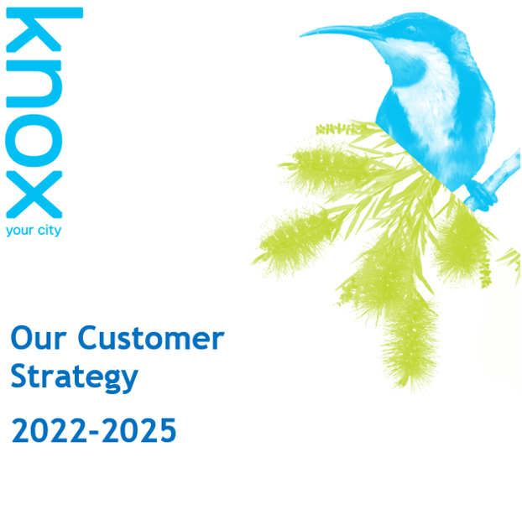
Table of contents
1 Introduction 2
1.1 Message from the Mayor 2
1.2 Message from the CEO 3
1.3 Strategy development 4
1.4 The purpose of our strategy 4
2 Customer Profile 5
2.1 Our customers 5
2.2 Customer needs 7
2.3 Customer segments 8
3 Council Services 10
3.1 Our services 10
3.2 Service performance 12
3.3 Balancing customer expectations with the roles of council 14
4 Strategy 15
4.1 Vision 15
4.2 Our values 15
4.3 Our customer promises 16
4.4 Goals and strategies 16
5 Way forward 17
5.1 Actions 17
5.2 Metrics 17
5.3 Key Success factors 18
5.4 Progress monitoring 18
5.5 Roadmap 19
5.6 Plan on a page 24

Introduction

Message from the Mayor


Cr Susan Laukens, Mayor
Never have we valued where we live more. We’ve all spent more time closer to home in recent years, and we are all paying much more attention to what is happening around us.
Council services go well beyond roads, rates, and rubbish to create this liveable place we are lucky enough to call home.
The moment you walk through your front gate onto the street, Council is there providing services many of us don’t give a second thought until something is not right.
Knox is a diverse community with many and varied needs and aspirations. Council has a long and proud tradition of providing services to help our community thrive and prosper. As our community changes, expectations are increasing of the services we provide for everyone.
As custodians of this magical part of the world we have a responsibility enshrined in law to balance the needs of everyone to achieve the best outcomes for the community, including future generations.
This includes ensuring the economic, social, and environmental sustainability of Knox and the ongoing financial viability of Council. It means we can’t always give customers exactly what they want and/or when they want it.
First and foremost, we are a service organisation. We know our customers are mostly understanding of the needs we must balance and the complexity of some of the services we provide. For our part, we want to do the best thing for the community.
This strategy describes the steps we will take to ensure we understand customer needs and priorities and measure our effectiveness in delivering services so we can direct our available resources to the things that matter most to our customers.

Message from the CEO

Bruce Dobson, Chief Executive Officer
Putting the customer at the centre of what we do is a core responsibility for all of us and is fundamental to delivering on the priorities set out in the new Council and Community Plan.
This strategy is a key deliverable on our commitment in the Council Plan to manage our resources effectively to ensure financial sustainability and improved customer experience.
Whether we have a role on the front line interacting with customers daily or play an enabling role, we all have a responsibility for how our customers experience us.
We deliver a staggering number and range of services. As our services have evolved so have our ways of doing things and for our customers that can result in an inconsistent experience depending on the service they require.
This strategy will guide a planned and pragmatic approach to building customer centric practices into the way the organisation operates, makes decisions, and designs its services for the community.
It will guide our service delivery to focus on customer experience, meeting customer needs through digital innovation and redesigning services.
The rising costs of providing services to a growing community and compounding impacts of rate capping are putting pressure on Council’s budget. We need to find new ways of releasing capacity to focus on the things that need more effort and add more value.
Understanding customer needs and priorities will be critical to achieving this. We have a committed and passionate team, who with the right tools, training and access to customer data and feedback can achieve the vision set out in this strategy.

Strategy development
This strategy has been developed following a rigorous research and consultation process, both with our customers and staff. To achieve a customer and data-driven final strategy, the following research was conducted:
- Review of recent customer research and performance results for various key services across Council.
- In-depth interviews of 11 senior managers and 11 frontline staff from a broad range of customer-facing functions.
- Online survey of all staff.
- Phone survey of 300 customers who had contact with Council within the previous three months.
- Online survey of 143 customers who transacted with Council via echannels within the previous three months.
- Workshops with key operational staff to journey map four services as case studies.
- Phone interviews of 40 customers of the four services to understand their experiences in depth.
- Demographic analysis and identification of the most dominant customer segments for Knox using Australia’s most comprehensive consumer classification dataset which provides household-level segmentation including demographics, financial attributes, lifestyles, attitudes, values, spend behaviour and channel engagement.
Following the analysis of this research, we conducted an in-depth codesign process, with staff from a range of high-volume service areas working together to develop the core elements and direction of the strategy.

The purpose of our strategy
This strategy guides the transformation of our service delivery to focus on the customer experience; to better meet customer needs through measures including digital innovation and service redesign; and to foster a customer centric service culture.
The strategy ensures our focus is on customers at the centre of everything we do. Over the last few years, we have all been reminded of the importance of community, connection, and community services.
As community members we have:
- Spent more time at home
- Explored our local area more
- Reached out to help and be helped by our neighbours and community
As a Council and service provider we have:
- Seen an increase in residents’ pride in their community
- Noticed increasing customer expectations of Council
- Experienced an increase in need for some of our services
- Noticed customers wanting to interact with Council in different ways
Knox’s inaugural Customer Experience Strategy has three main purposes.
- Deliver better customer service for customers to:
- Enjoy a better user experience
- Have easier access to information and services
- Use 24/7 self-service for simple services
- Get more support on complex services and build deeper relationships along the journey
- Deliver a modern, cost effective, and sustainable approach for customer service that will:
- Expand service channels – more digital plus more choice
- Increase ease and efficiency for staff with streamlined processes
- Deliver existing services more efficiently
- Build improved capabilities, value added services, going the extra mile
- Help coordinate our internal programs:
- Digital innovation
- Service redesign
- CX culture

Customer Profile

Our customers
We have a more diverse range of customers than most organisations across all life stages, abilities, needs and household types. Our customers include residents and non-resident rate payers, business owners, workers, visitors and community service users. Our services and customer service need to accommodate this diversity.
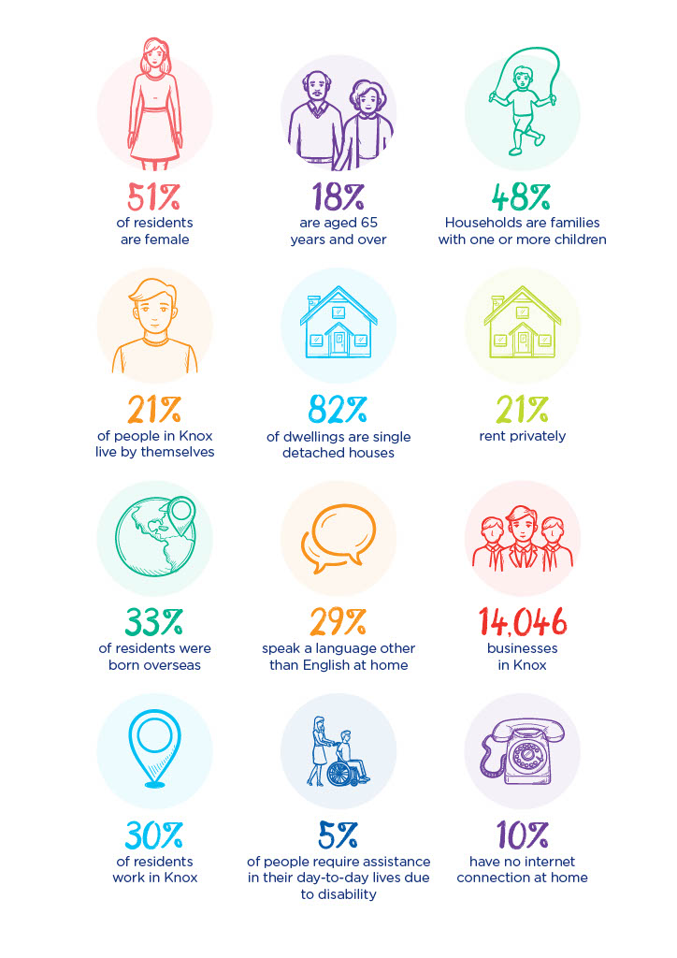

Customer needs
Customer research indicates that there are opportunities to realign service delivery channels and reallocate resources to better meet customer needs and priorities.
Customers are increasingly using e-channels. Almost 50% of customers now access the website before calling Council.
More than 70% of phone enquiries to Council are for information or simple requests. The majority of these can be transitioned to e-channels, while always preserving the option of calling for those who prefer. Surprisingly only 14% of customers prefer calling council to seek information.
By increasing the availability of e-channels we can provide customer benefits, particularly easy mobile access and the convenience of 24/7 access to council services.
Increased use of e-channels will enable us to free up staff from dealing with simple requests and spend more time on complex requests and going the extra mile with customers to help identify and voice their needs.
Realignment of service delivery channels with customer preferences will provide a more efficient and sustainable customer service model.
Customer feedback shows the attributes customers value the most are staff going the extra mile, being given the correct information and dealing with knowledgeable staff.
Customers told us they value knowledgeable and professional staff who listen to, and understand, customer needs and take accountability for resolving customer requests.

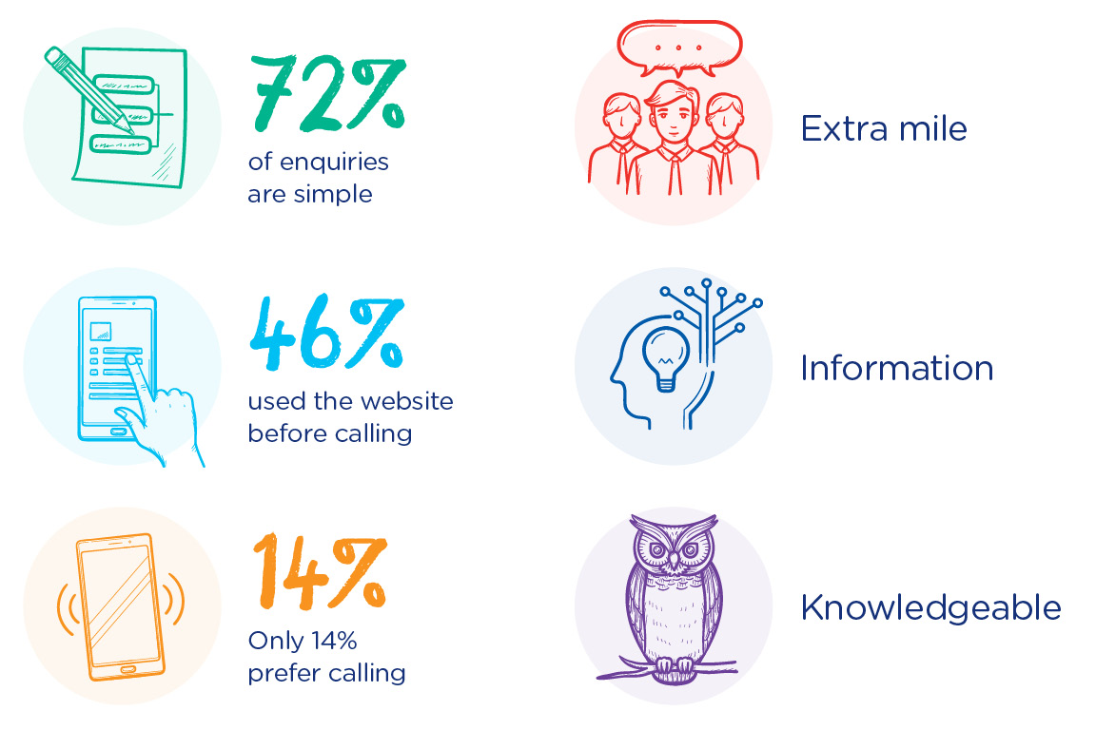
Source – CSBA Voice of the Customer Survey, 2022

‘Because it was easy, they got onto me straight away. No need to call back.’
‘It was just prompt. Both people I dealt with were very professional. She was very friendly, and helpful. She didn't know the answer but she got someone to call me back from the right department.’
‘We didn't have to follow up anything. It was straightforward.’
‘I was given clear information, and I didn't really have to ask further questions.’
‘The consultant was excellent. They were able to listen to where the query needed to go, they let me know what was happening. They were very personable and fantastic communication.’

Source – CSBA Voice of the Customer Survey, 2022

Customer segments
In order to provide a more personalised service and understanding of customer needs, we have identified six key customer segments for Knox.
Over time we will capture personal preferences and special needs for all our customers. We will start refining our services based on customer segments and personas representing those segments.
As our customer relationship management capabilities improve, we will be able to track individual customer journeys, anticipate customer needs and help customers more proactively.
Customer segmentation will help us to:
- Improve service design by
- Tailoring services to customer needs
- Enabling flexibility to deal with individual requirements
- Improve service delivery by
- Providing a better understanding of customer priorities
- Communicating with customers according to their preferences
- Support a customer centric culture by
- Helping staff to ‘walk in the customer's shoes’
- Encouraging staff to anticipate and respond to unspoken needs
The six customer segments were developed using a tool that collates more than a thousand commercially available data sets from various sources. This provides a detailed and granular view of socio-demographic profiles at a household and neighbourhood level to enable a rich and detailed understanding of consumer behaviours and preferences. The following six segments directly represent 56% of residents plus another 26% of residents who are in 'similar’ segments.

Profile | Description | % of Knox households | Aspirations | Pain Points
Spacious traditions   | Middle aged families with school children | 14% | Work life balance  Looking and feeling good | Getting the run around  Wasting time
New found freedom   | Established mature families with adult children | 14% | Connection to community  Reducing environmental footprint | Inconsistency  Disconnects between different Council services
Schools and bills   | Younger families with young children | 9% | Healthy fun for family  Paying off mortgage | Safety concerns around children growing up  Things taking too long
Backyards and mates   | Single, younger middle Australia | 8% | Settling down, owning a home  Making the sporting team | Getting the run around  Work-life balance around commuting
Realistic horizons   | Couples, divorced singles or never married | 7% | Rebuilding economic self sufficiency  Staying fit and healthy | Feeling isolated  Lacking confidence to participate
Solo seniors   | Single retirees living in outer suburbs | 4% | Family time with grandkids  Maintaining independence | Adapting to change  Being patronised due to age

Council Services

Our services
We provide services to support community members throughout their lives. The range of services provided by local government is more diverse than any other sector. This diversity of services presents challenges and requires a complex range of capabilities, systems, and skills.
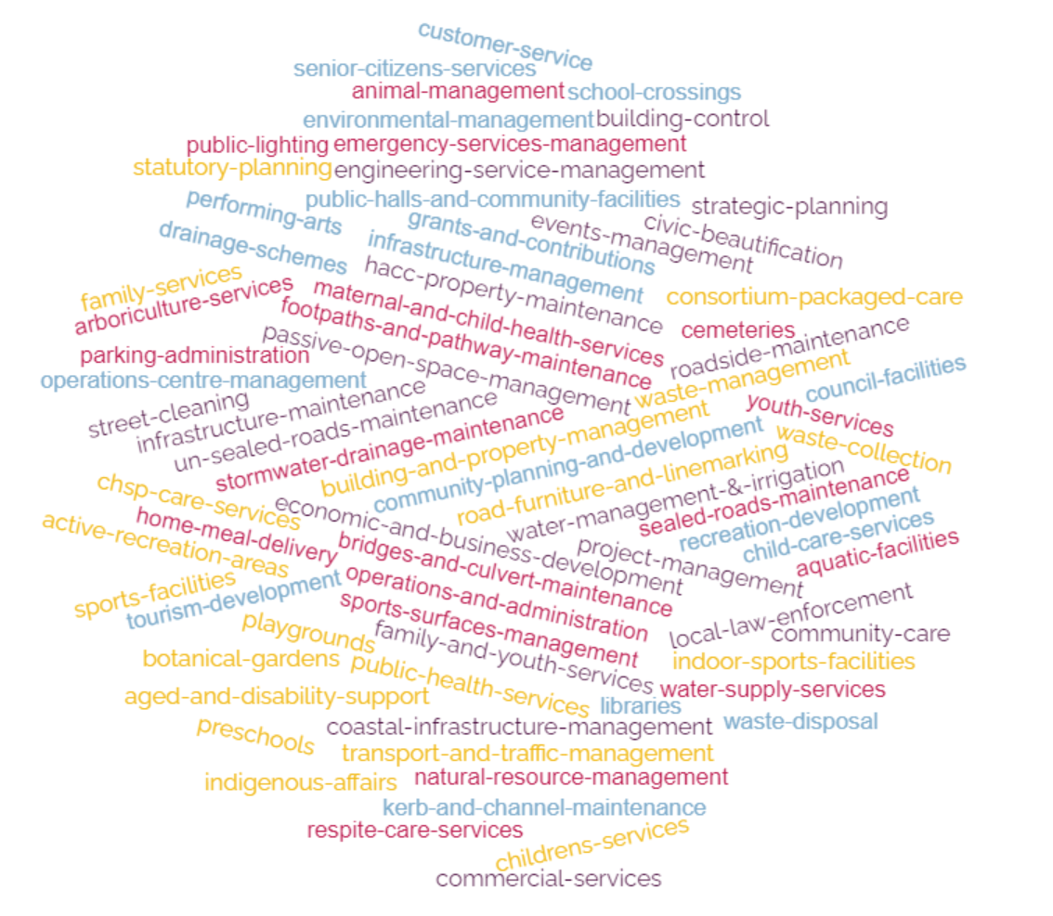
This strategy will help us deliver dual aspirations for our services, that is, continual improvement of service delivery in each team and a more consistent, organisation wide approach to customer experience.

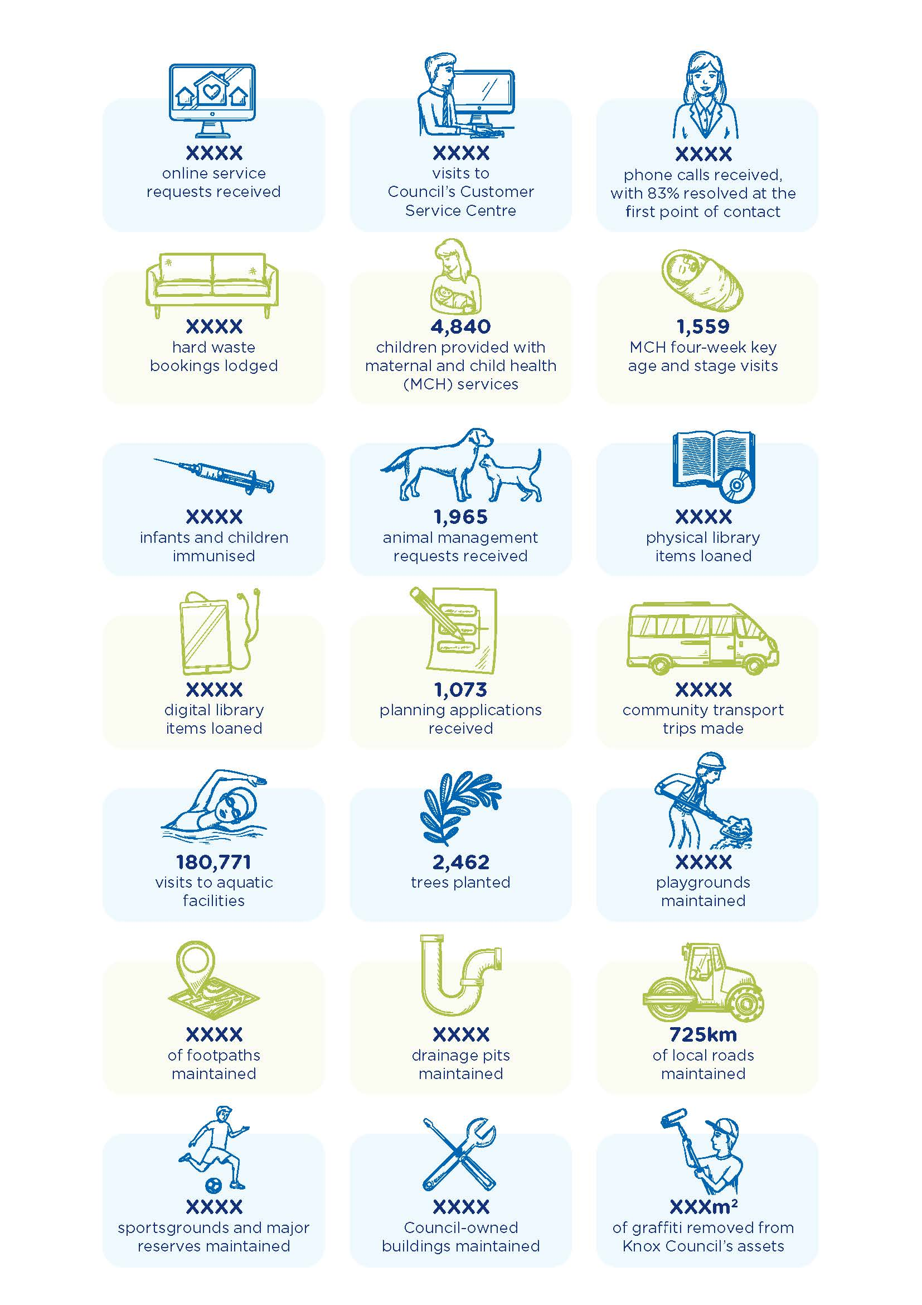

Service performance
Customer research has shown encouraging baseline performance results across a number of key customer experience measures. Benchmarking results against 10 other participating councils revealed that we performed above average in several key metrics, including overall customer satisfaction, ease, first point of contact resolution and service delivery satisfaction, as shown below.
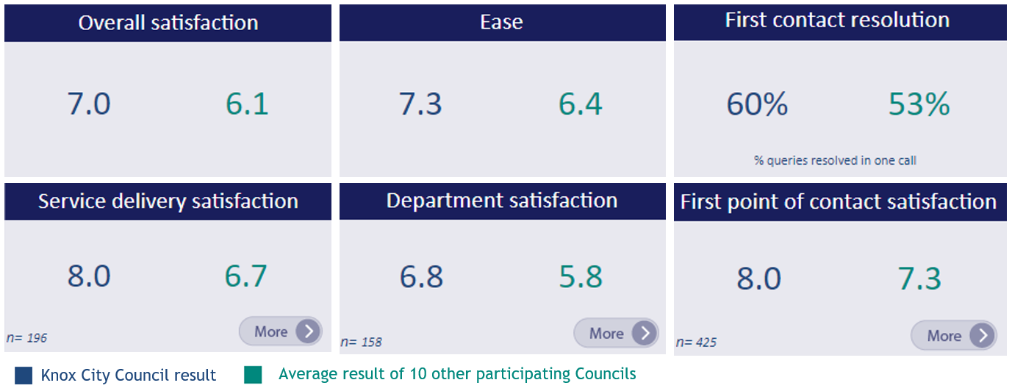
Source – CSBA CX Benchmarking Program, 2022

Despite these encouraging results, detailed analysis of customer feedback shows distinct gaps in service delivery. There are two main opportunities for improvement.
- By channel – Council can increase the availability of online self-service and improve user experience to provide customers with the same ease and satisfaction as staffed channels and encourage customers towards lower cost e-channels.
- The e-channels, including online forms and emails, are perceived as difficult and unsatisfactory.
- A greater proportion of customers expressed dissatisfaction (37%) with the website than high satisfaction (31%).
- The phone channel is perceived as easier (8.0 vs 5.8) and more satisfactory (7.8 vs 5.3) than e-channels.
- This disparity in service perceptions by channel is driving customers from using lower cost e-channels to high-cost channels including phone and in person at the customer service counter.
- 54% of contacts were simple requests that may be able to be managed online.
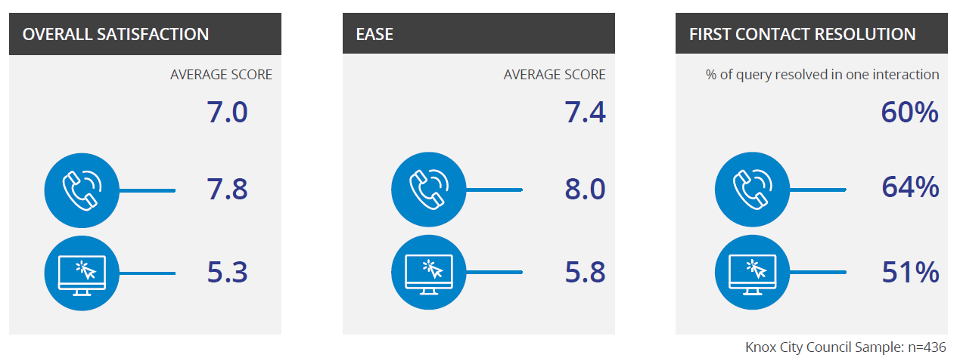
Source – CSBA Voice of the Customer Survey, 2022

- By service type – Council can streamline ’complex’ services with a concierge or case management approach to improve customer outcomes and satisfaction.
- Satisfaction with simple services is significantly higher (7.9) than complex services (6.3)
- Sentiment analysis of customer verbatim feedback shows that human factors have an overwhelmingly positive sentiment, whereas process factors have as much negative as positive sentiment
- These insights indicate that expert staff should be freed up from simple service requests and requests for information (72%) to allow more attention on complex services (28%).

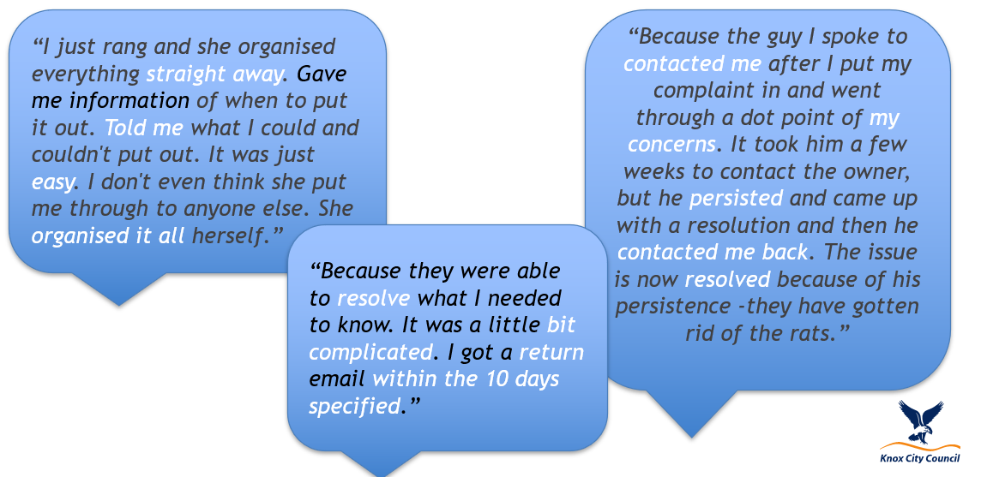
Source – CSBA Voice of the Customer Survey, 2022

Balancing customer expectations with the roles of council
Council has many roles, each with obligations and responsibilities. Sometimes we cannot give a customer the outcome they desire. Sometimes an individual request clashes with our obligations to the community or our legal obligations. When this occurs, we need to spend time with customers to help them understand what we can do and what we can’t do.
We want to offer individual customers the best experience that we can, while balancing our obligations to others.
Setting realistic expectations is important so that customers:
- Make realistic, actionable requests
- Have less cause for disappointment, which may lead to escalations

Case study: Balancing different customer needs and regulatory roles
Sathya and Raj’s adult children have recently moved out of the family home. They want to build a new townhouse in their backyard to live in, subdivide and sell their family home to downsize their mortgage so they can retire sooner.
Sathya makes a planning application to build the townhouse and subdivide.
Their neighbours, Emily and Zac have three children under eight. They are concerned that a two-storey townhouse at the rear of the block will overlook their backyard where their children play and they entertain friends and family.
Emily lodges an objection to the planning application to build a townhouse at the back of the block.
Lily has lived most of her life on the same street and is fond of two large trees within Sathya and Raj's backyard. Lily lodges an objection to the application in response to plans to cut down the two large trees to make way for the new townhouse.
Kylie is the Council planning officer who assesses the planning application and the objections. Kylie must ensure that the planning application complies with the rules set out in the Knox Planning Scheme for the property. She considers all the objections and seeks to mediate a solution that meets the planning scheme and all customer needs, even though they are conflicting. She approves the application with conditions that require windows overlooking Emily’s backyard to be obscured and replacement tree planting.
While Sathya, Emily or Lily may not get exactly what they want, they all get a fair hearing, they understand the reasons for the decision and the service experience is respectful, clear and timely.

Strategy

Vision
Our vision will guide our aspirations and journey.
Our customers are highly satisfied because we are easy to deal with, our services meet their needs and our people go the extra mile to help while balancing our community obligations.

Our values
Our values are the foundations to our success and culture at Knox. They represent what we stand for, inspire us, and create a shared understanding to align the way we work with our vision and purpose. Here’s how they can be applied to achieving great customer outcomes.

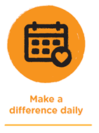 | We are friendly and helpful. We listen to understand what it is our customers’ need. We return calls and respond to emails promptly, tell customers what we can do to help or where else they can get help.  We help customers understand what happens next and the likely timeframe. We do what we say we are going to do and keep customers in the loop of our progress. We encourage customers to provide feedback when something isn’t right, and we take quick action to resolve problems.
 | We actively seek feedback from customers to help us design services and processes to match customer needs. We are curious about how well our services are meeting customer needs. We use customer feedback to make changes and improve our services.  We measure our performance and our customers’ satisfaction to understand how we can make the best use of our resources. We analyse complaints to learn and improve and empower our frontline staff to resolve problems. We celebrate great customer moments and inspire our teams to achieve outstanding customer outcomes.
 | We see opportunities to improve how our customers experience us and feel compelled to try new things. We challenge the status quo and actively seek out ways to reimagine how we deliver services.  We share our success, learn from each other, and build on ideas to achieve better outcomes for our customers. We reach beyond our own remit, collaborate with other teams, and find a way to make our ideas come to fruition.
 | Each of us are accountable for upholding our customer promises. We encourage good and bad feedback. We respond promptly and professionally even when delivering bad news or having difficult conversations.  We take responsibility for coordinating a response when there is more than one team involved in achieving a resolution and help our customers navigate the complexity of Council.

Our customer promises
Our customer promises are our commitments to our customers.
- We care: we listen and take the time to understand you and what you need
- We’re helpful: we’re easy to deal with, professional and focussed on clear, practical outcomes
- We’re fair: we work to meet your needs, while balancing our community obligations
- We’re knowledgeable: we’ll let you know what we can do to help and help you anticipate what else you might need
- We’re accountable: we’ll guide you through the next steps, always follow through, work with our colleagues and keep you informed of our progress

Goals and strategies
Our goals and strategies summarise the key areas of focus for us over the next three years. These strategies will strengthen the foundations for a more sophisticated approach to customer experience, an approach that will provide customers with a better experience and be more cost effective and sustainable for Council. The strategies define our ongoing programs of work throughout 2022-2025 that support our goals and coordinate our actions.

Goals | Strategies
1 - Understand our customers needs and priorities | 1.1 - Develop an ongoing customer listening program
1 - Understand our customers needs and priorities | 1.2 - Create and maintain a single view of customer interactions
1 - Understand our customers needs and priorities | 1.3 - Develop a more personalised customer understanding
2 - Improve our customer service capabilities | 2.1 - Increase choice and flexibility of channels for contacting Council and receiving updates
2 - Improve our customer service capabilities | 2.2 - Develop more user-friendly self-service options
2 - Improve our customer service capabilities | 2.3 - Provide more visibility of the status of requests and complaints
2 - Improve our customer service capabilities | 2.4 - Build capability to design services that meet customer needs
3 - Build a customer focused culture | 3.1 - Embed a CX focus in organisational strategy and planning
3 - Build a customer focused culture | 3.2 - Establish CX service delivery standards and expectations
3 - Build a customer focused culture | 3.3 - Build a positive culture and good practice in complaint handling
3 - Build a customer focused culture | 3.4 - Promote clear accountability for customer satisfaction among staff
3 - Build a customer focused culture | 3.5 - Invest in improved staff CX awareness and skills
4 - Use data to drive better performance | 4.1 - Establish an organisation-wide CX performance measurement and monitoring program
4 - Use data to drive better performance | 4.2 - Enable transparency of CX performance
4 - Use data to drive better performance | 4.3 - Develop a better understanding of the economics of service

Way forward

Actions
Actions have been identified to progress each strategy in pursuit of our goals and long-term vision. The actions form a roadmap with timeframes, costings and accountabilities.
Actions have been selected to align with and leverage other organisational initiatives and business planning practices to embed customer focus in our everyday work. They are pragmatic and practical for teams to implement. Actions that require upfront investment of time and resources will have a pay back in time and resource savings from improving customer experience and reducing administrative effort, enabling resources to be redirected to more high value work.

Metrics
Metrics and the associated monitoring program will track our implementation progress and customer experience improvements. Key Performance Indicators (KPIs) will focus on a few metrics that matter most, and will apply at all levels, at a service, departmental, divisional and organisational level. These will include:
- Customer satisfaction. This measures the sentiment, the feeling and emotion, of a customer interaction or relationship. Understanding the drivers of customer satisfaction and robust data on these will be critically important as insights at the driver level will provide guidance for continuous improvement initiatives.
- Ease. This measures how easy the customer found it to deal with Council. This is an important measure to help in a resource constrained environment. Processes that are easy for customers are often more cost efficient.
- Success. These are measures of service delivery, service outcomes and include a measure of time and a measure of quality.
- Cost to serve. This can be included when we build the technology capabilities and data collection regimes to support accurate measurement.

Key success factors
The implementation plan will include a change management plan which is considerate of:
- Making organisation wide customer experience initiatives practical for each team.
- Providing staff with ongoing support to make and sustain changes.
- Aligning the CX roadmap with other major initiatives, especially Thrive and the ICT Strategy.
- Embedding a customer focus in our ways of working, rather than adding customer experience as an extra requirement.
- Utilising existing capabilities, and leveraging examples of internal best practice.
Addressing these key success factors in implementation will increase the probability of successful outcomes.

Progress monitoring
Progress monitoring will be conducted in two streams:
- Program management monitoring, involving:
  - Monitoring the progress of projects to schedule and budget
  - Monitoring project milestones and deliverables
- Customer experience monitoring, involving:
  - Monitoring of customer experience outcomes and improvements due to project implementation
  - Measuring project benefits
  - Establishing an expected outcome at the start of each project and measuring impacts post-implementation to increase benefits realisation
Reporting will be communicated regularly to the organisation and the community. A midpoint review will be conducted to ensure the programs identified in the roadmap are achieving the goals of the strategy.

Roadmap
Goal | Strategy | Action | Y1 | Y2 | Y3 | Cost | Partners
1 - Understand our customers needs and priorities | 1.1 - Develop an ongoing customer listening program | 1.1.1 - Implement a Voice of the Customer program and roll out organisation wide, automated customer listening surveys |  |  |  | $50k (year 1)  $40k (p/a ongoing) within budget | Chief Information Officer
1 - Understand our customers needs and priorities | 1.1 - Develop an ongoing customer listening program | 1.1.2 - Identify opportunities through business planning and service review processes to capture customer feedback at the service level |  |  |  | Within existing resources | Strategy and Transformation
1 - Understand our customers needs and priorities | 1.2 - Create and maintain a single view of customer interactions | 1.2.1 - Improve master data management, include consolidating the NARs (name and address registers) |  |  |  | $1.25m budgeted in ICT Strategy | Customer and Communications
1 - Understand our customers needs and priorities |  | 1.2.2 - Implement a CRM (customer relationship management) system |  |  |  | $1.68m budgeted in ICT Strategy | Customer and Communications
1 - Understand our customers needs and priorities | 1.3 - Develop a more personalised customer understanding | 1.3.1 - Build a library of customer personas |  |  |  | Within existing resources
1 - Understand our customers needs and priorities | 1.3 - Develop a more personalised customer understanding | 1.3.2 - Develop a customer profile standard to inform CRM design |  |  |  | Within existing resources
2 - Improve our customer service capabilities | 2.1 - Increase choice and flexibility of channels for contacting Council and receiving updates | 2.1.1 - Capture individual customer contact preferences |  |  |  | Within existing resources
2 - Improve our customer service capabilities |  | 2.1.2 - Conduct a trial of live chat |  |  |  | Within existing resources
2 - Improve our customer service capabilities | 2.2 - Develop more user friendly self-service options | 2.2.1 - Develop a Digital Roadmap |  |  |  | $66k within budget
2 - Improve our customer service capabilities | 2.2 - Develop more user friendly self-service options | 2.2.2 - Improve the user experience of ePathway forms |  |  |  | Subject to prioritisation in Pathway program ($90k p/a within budget) | Customer and Communications
2 - Improve our customer service capabilities | 2.2 - Develop more user friendly self-service options | 2.2.3 - Replace PDF forms with online forms |  |  |  | Within existing resources
2 - Improve our customer service capabilities | 2.2 - Develop more user friendly self-service options | 2.2.4 - Integrate online forms with Pathway to eliminate ePathway |  |  |  | $525k budgeted in ICT Strategy | Customer and Communications
2 - Improve our customer service capabilities | 2.3 - Provide more visibility of the status of requests and complaints | 2.3.1 - Set up automated email and SMS progress updates for customer requests |  |  |  | Subject to prioritisation in Pathway program ($90k p/a within budget)
2 - Improve our customer service capabilities |  | 2.3.2 - Set up automated emails on next steps and timeframes tailored to each service |  |  |  | Within existing resources | Chief Information Officer
2 - Improve our customer service capabilities |  | 2.3.3 - Review web content to ensure that next steps and timeframes are clear for all request and application types |  |  |  | Within existing resources
2 - Improve our customer service capabilities |  | 2.3.4 - Integrate Confirm with Pathway |  |  |  | $1.5m budgeted in ICT Strategy for Confirm project | Chief Information Officer
2 - Improve our customer service capabilities |  | 2.3.5 - Develop functionality on the website to allow customers to check the status of their requests online without having to log on |  |  |  | Cost to be confirmed | Chief Information Officer
2 - Improve our customer service capabilities |  | 2.3.6 - Establish an online customer portal for customers to view progress of requests and personal transactions |  |  |  | $525k budgeted in ICT Strategy | Customer and Communications
2 - Improve our customer service capabilities | 2.4 - Build capability to design services that meet customer needs | 2.4.1 - Develop a customer journey mapping methodology and program linked to ICT investment, service reviews and business planning |  |  |  | Within existing resources
2 - Improve our customer service capabilities |  | 2.4.2 - Develop service design capability |  |  |  | Subject to future budget deliberation
3 - Build a customer focused culture | 3.1 - Embed a CX focus in organisational strategy and planning | 3.1.1 - Recruit a Customer Experience Lead to lead implementation of the strategy |  |  |  | $137k within budget
3 - Build a customer focused culture |  | 3.1.2 - Develop a communication and change management plan to implement the Customer Experience Strategy internally |  |  |  | $5k within budget
3 - Build a customer focused culture |  | 3.1.3 - Incorporate customer experience in scheduled reviews of other organisational strategies e.g. Thrive, ICT Strategy |  |  |  | Within existing resources | Chief Information Officer
3 - Build a customer focused culture |  | 3.1.4 - Incorporate a CX focus in the annual business planning process |  |  |  | Within existing resources | Strategy and Transformation
3 - Build a customer focused culture |  | 3.1.5 - Incorporate a CX focus in any service reviews |  |  |  | Within existing resources | Strategy and Transformation
3 - Build a customer focused culture |  | 3.1.6 - Build a CX focus into existing reward and recognition programs |  |  |  | Within existing resources | People, Culture and Development
3 - Build a customer focused culture | 3.2 - Establish CX service delivery standards and expectations | 3.2.1 - Develop a Customer Charter and promote internally among all staff |  |  |  | Within existing resources
3 - Build a customer focused culture |  | 3.2.2 - Establish standard timeframes for all services |  |  |  | Within existing resources
3 - Build a customer focused culture |  | 3.2.3 - Publish the service standard timeframes of all key services on our website |  |  |  | Within existing resources
3 - Build a customer focused culture | 3.3 - Build a positive culture and good practice in complaint handling | 3.3.1 - Review the Complaints Policy |  |  |  | Within existing resources | Governance
3 - Build a customer focused culture |  | 3.3.2 - Develop a complaints handling procedure and train all staff |  |  |  | Within existing resources | Governance
3 - Build a customer focused culture |  | 3.3.3 - Provide insights on complaint data to service managers to identify opportunities for improvement |  |  |  | Within existing resources
3 - Build a customer focused culture | 3.4 - Promote clear accountability for customer satisfaction among staff | 3.4.1 - Add customer responsibilities to all new and existing position descriptions |  |  |  | Within existing resources | People, Culture and Development
3 - Build a customer focused culture |  | 3.4.2 - Investigate opportunities to extend the case management approach for complex services |  |  |  | Within existing resources | Governance
3 - Build a customer focused culture |  | 3.4.3 - Include customer metrics in the roadmaps of all staff |  |  |  | Within existing resources
3 - Build a customer focused culture | 3.5 - Invest in improved staff CX awareness and skills | 3.5.1 - Deliver CX awareness training to all staff |  |  |  | $30k within budget
3 - Build a customer focused culture | 3.5 - Invest in improved staff CX awareness and skills | 3.5.2 - Deliver ongoing CX training to all staff |  |  |  | Within existing resources | People, Culture and Development
3 - Build a customer focused culture | 3.5 - Invest in improved staff CX awareness and skills | 3.5.3 - Capture, share and celebrate examples of best practice |  |  |  | Within existing resources
4 - Use data to drive better performance | 4.1 - Establish an organisation-wide CX performance measurement and monitoring program | 4.1.1 - Refine organisation-wide CX metrics and targets |  |  |  | Within existing resources
4 - Use data to drive better performance |  | 4.1.2 - Develop a quarterly CX performance report |  |  |  | Within existing resources
4 - Use data to drive better performance |  | 4.1.3 - Set up a formal CX Improvement program to improve customer satisfaction results |  |  |  | Within existing resources
4 - Use data to drive better performance | 4.2 - Enable transparency of CX performance | 4.2.1 - Develop CX dashboards with performance results at a service, departmental, divisional and organisational level |  |  |  | Within existing resources | Customer and Communications
4 - Use data to drive better performance | 4.2 - Enable transparency of CX performance | 4.2.2 - Explore opportunities to expose CX dashboards on new corporate intranet |  |  |  | Within existing resources | Chief Information Officer
4 - Use data to drive better performance | 4.2 - Enable transparency of CX performance | 4.2.3 - Make CX performance results available publicly |  |  |  | Within existing resources
4 - Use data to drive better performance | 4.3 - Develop a better understanding of the economics of service | 4.3.1 - Calculate and track the cost per transaction for each contact channel |  |  |  | Within existing resources

*Timing estimates and costs to be confirmed.

Plan on a page
