Help shape the future of the parks, reserves, playgrounds and open spaces you love in Knox
Big parks, tiny parks… and every space in between. In Knox, open space is more than just parks, it includes our reserves, bushland, sports fields, nature strips, trails, waterways, civic spaces and shopping villages. These are the places where we play, connect, exercise, relax and spend time together.

As Knox grows, these spaces will matter more than ever. With more people, changing lifestyles and fewer private backyards, we need to plan and care for our open spaces carefully to ensure they remain high quality, accessible and able to meet community needs now and into the future.

That’s why Council is developing a long term Open Space Strategy to guide how open spaces across Knox are planned, improved and cared for in the future.

From 6 July to 16 August, we’re inviting you to share what matters most to you about the parks, reserves, playgrounds and open spaces you use. Your feedback will help shape important decisions about how these spaces are protected, shared and enhanced and how we balance recreation, nature and community life as Knox grows.

Have your say on the Open Space Strategy and help shape the future of the places that shape Knox.

Find out more and have your say at: haveyoursay.knox.vic.gov.au/ShapeOurParks

Community engagement closes 16 August 2026.

You may submit this survey to Council –

In person or by mail to:  Strategic Open Space Planning Team  Knox City Council  511 Burwood Highway  Wantirna South VIC 3152 | Email:  Knoxcc@knox.vic.gov.au
For more information or for assistance completing the survey call the Strategic Open Space Planning Team on 9298 8000.

Privacy Statement
We handle any personal information you provide in this form in accordance with the Privacy and Data Protection Act 2014. For more information, see our Privacy Policy. https://www.knox.vic.gov.au/our-council/legislation-and-local-laws/your-privacy

Community survey

Survey section 1

Tell us about the open spaces you use in Knox
- Which open spaces you visit
- What activities you use it for
- What you like about the space, or what could be improved
- What facilities or equipment you use or would like to see.

Survey section 2

Your perfect experience

- If you had one wish for your perfect open space experience in Knox, what would it be?

Increasing our natural biodiversity corridors

More varied planting in parks
There are benefits to changing from traditional parks with trees and mown grass, to support more varied planting utilising shrubs and alternate grasses and wildflowers. The aim is to bring our parks to life with a wider variety of plants.
Adding more native plants to underused areas can support local wildlife and reduce maintenance costs, while keeping open grass areas for recreation. These would be provided at under-utilised areas within our reserves, noting that there would still be spaces where traditional mown grass would be essential to meet the needs of formal and informal sport and recreation.
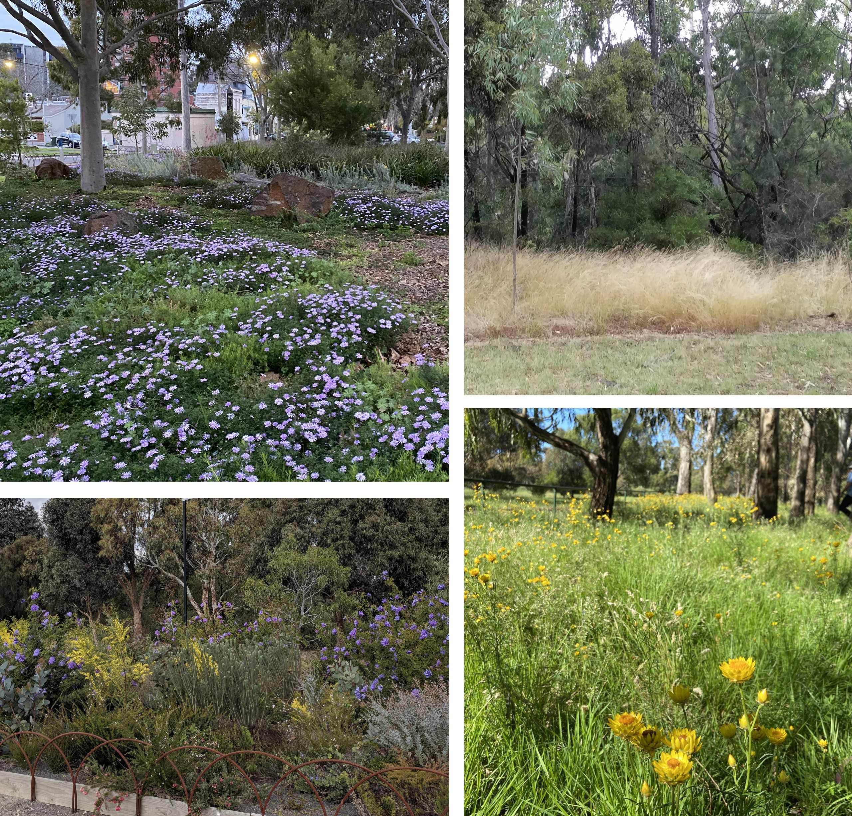
Images for illustrative purposes only*
- How would you feel about a shift to preference more low-maintenance, alternate ground coverage and native planting styles in suitable areas as an alternative to lawn and grass? These would be delivered away from structured sporting activities areas.
Select one answer only

Strongly dislike
Dislike
Neutral
Like
Strongly like
- Tell us why:
Greening local streets
We’ve heard how much our community loves having nature close to home.
By redesigning local residential streets, we could bring more nature into neighbourhoods. This would help make streets cooler and make it easier for native plants and animals to move through the area and thrive.
These changes could also affect how parking and footpaths are planned. If they were to be introduced, local conditions would be considered.
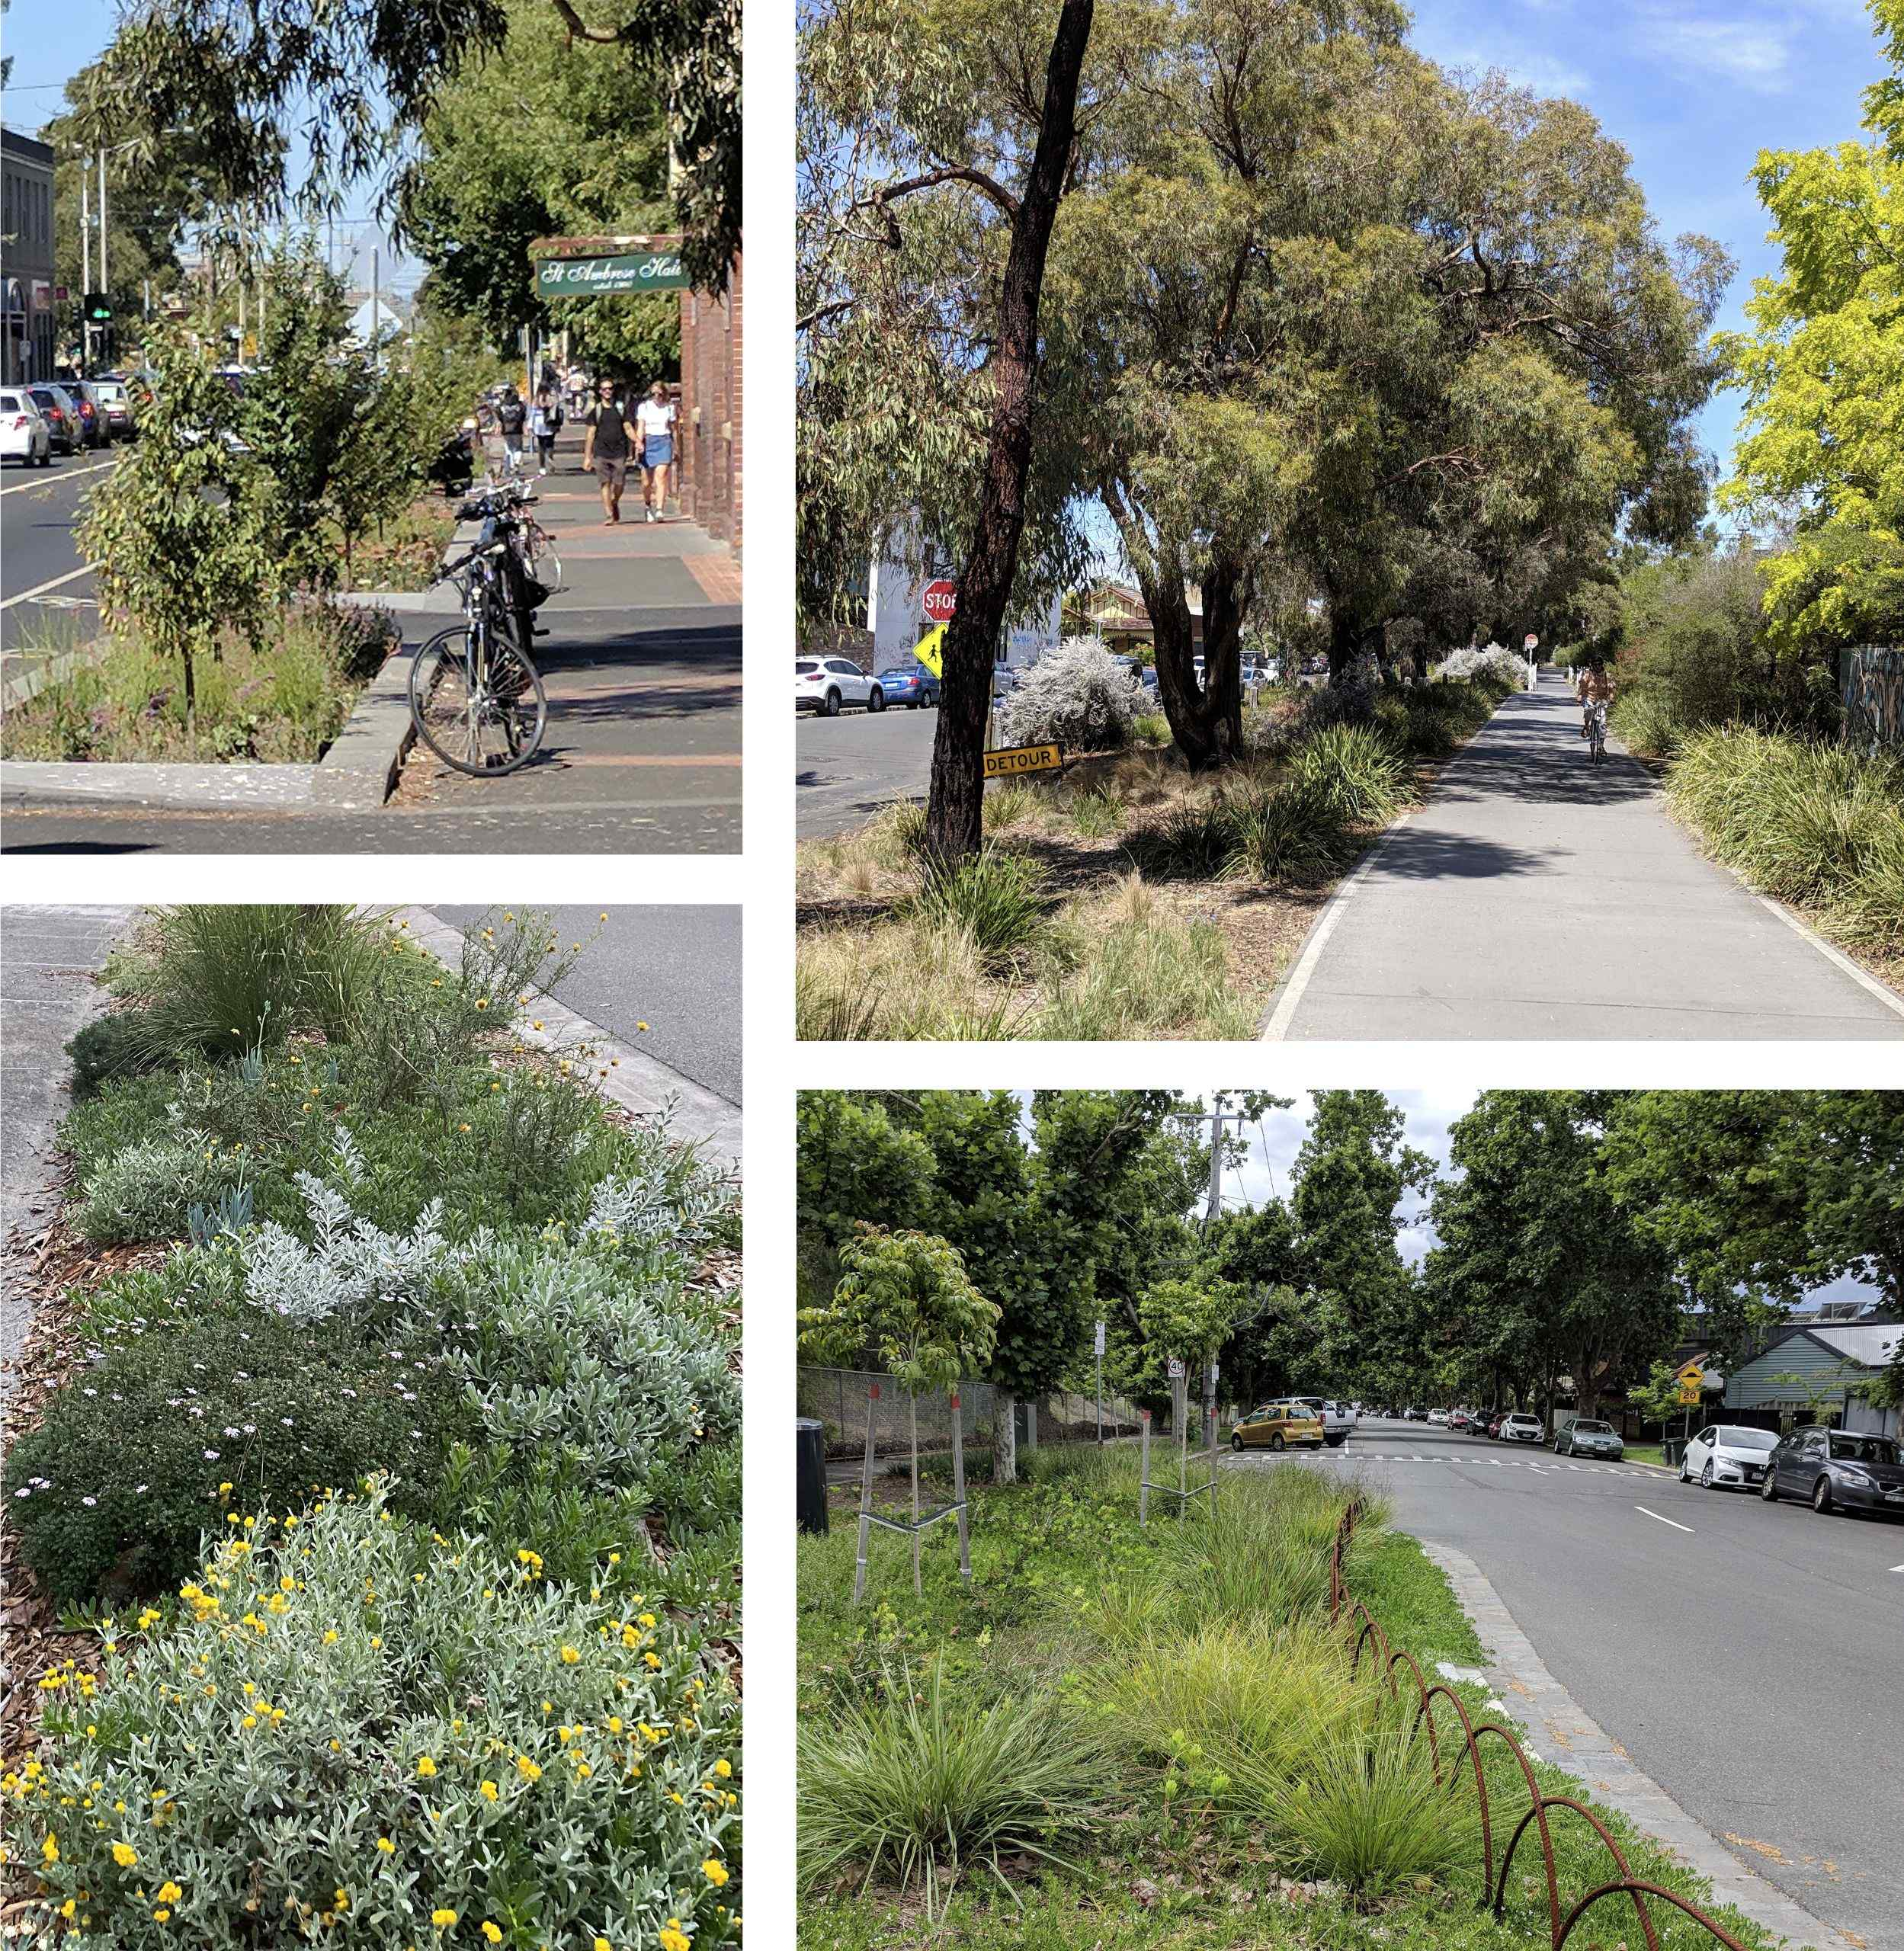
Images for illustrative purposes only*
- How do you feel about a change to the design of streets to prioritise shady paths and planting?
Select one answer only
Strongly dislike
Dislike
Neutral
Like
Strongly like
- Tell us why:

Playgrounds
There are more than 200 playgrounds in Knox, including many small, basic playgrounds. These are often within walking distance of your home or a very short drive. We’ve heard from the community that these small playgrounds mainly suit very young children, use traditional equipment and have limited natural features.
We want to improve the mix of playgrounds across Knox so that they cater to a variety of ages and activities.
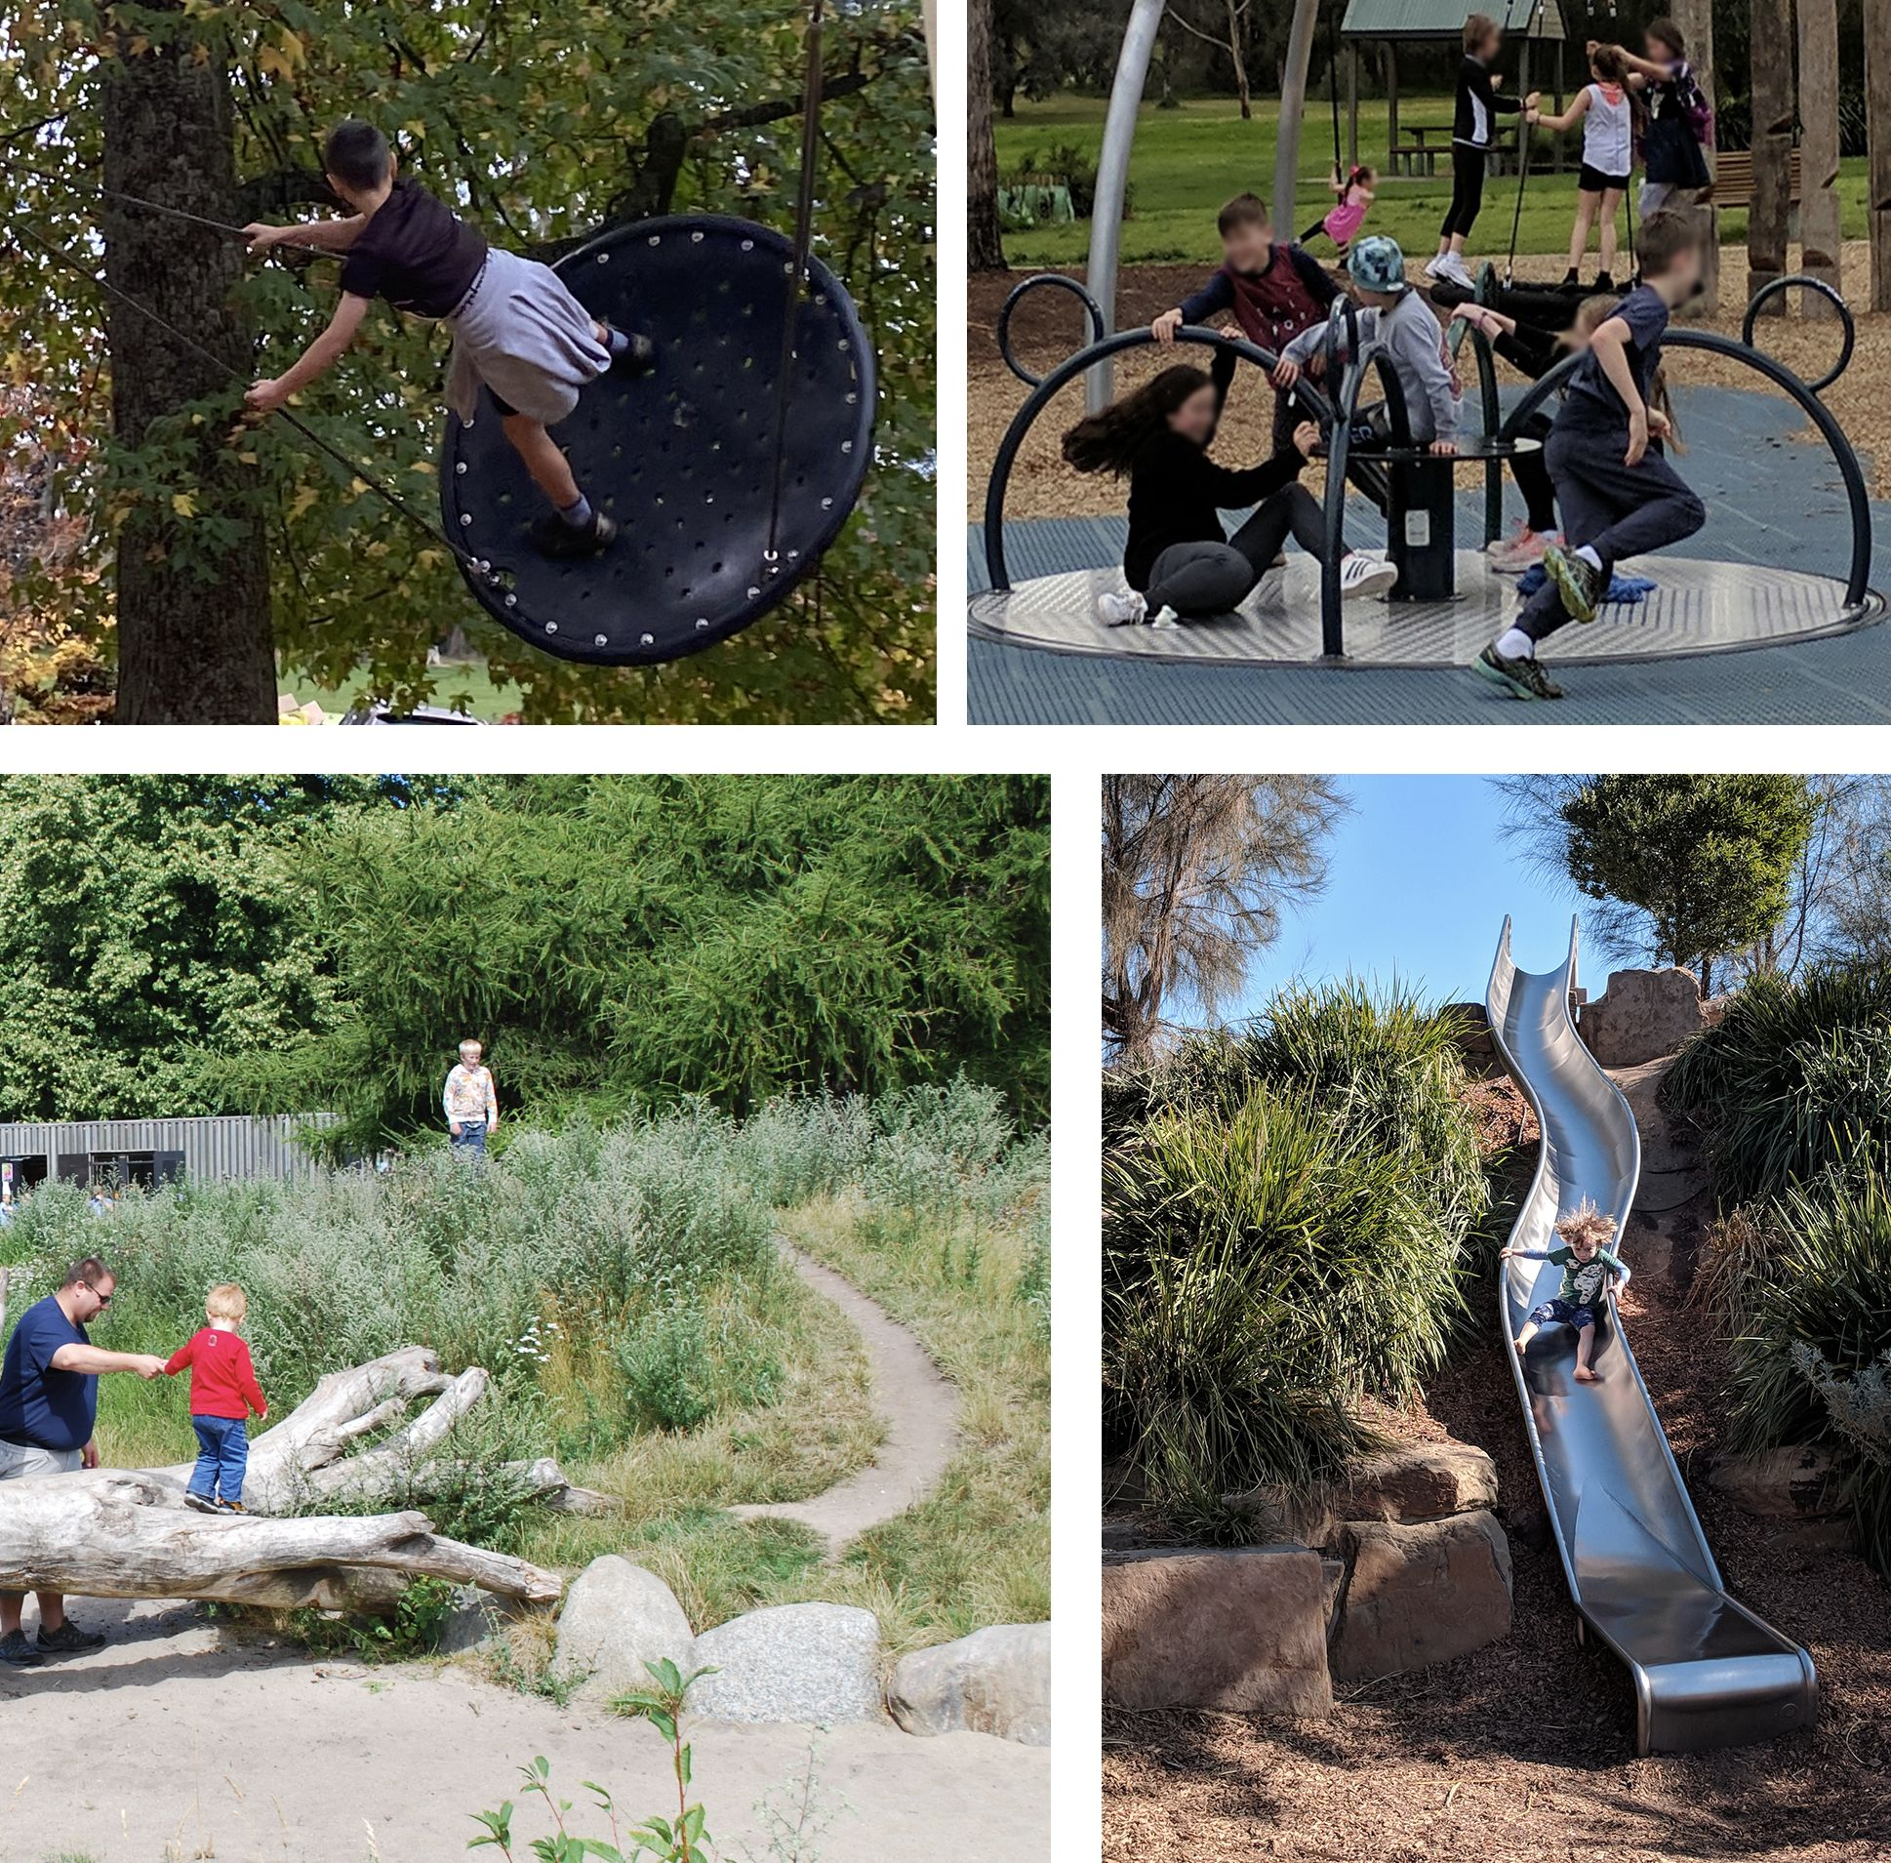
Images for illustrative purposes only*
- How do you feel about prioritising higher-quality playgrounds and offering a wider range of play experiences?
- Select one answer only
Strongly dislike
Dislike
Neutral
Like
Strongly like
- Tell us why:

About you
We'd like to know a little more about you. This helps us understand how different people use and enjoy open spaces, as well as any barriers they might face.
- How do you describe your gender?
Select one answer only
Woman
Man
Non-binary
Prefer not to say
Prefer to self-describe (please specify):

- What is your age?
Select one answer only
Under 18
18-24
25-44
45-64
65-74
75+
Prefer not to say
- Where do you live?
Select one answer only (If you don't live in Knox, indicate which suburb you spend the most time in)
Select one answer only
Bayswater
Boronia
Ferntree Gully
Knoxfield
Lysterfield
Rowville
Sassafras
Scoresby
The Basin
Upper Ferntree Gully
Wantirna
Wantirna South
Other

- Do any of the these apply to you?
Select all that apply

I am an Aboriginal or Torres Strait Islander
I speak a language other than English at home
I have little or no outdoor space at home
I have a disability, or I care for someone with a disability, that affects access to open spaces
I am part of a group or organisation that regularly uses open space in Knox
I am a parent or carer of a child or children
- If you indicated in question 11 that you are a part of a group or organisation that regularly uses open space in Knox, tell us:
Select all that apply
Community garden
Friends of or environmental group
Sports or leisure club
Other

- If you indicated in question 11 that you speak a language other than English at home, please specify which language(s):
- If you indicated in question 11 that you are a parent or carer of a child, how old is the child or children?
- If you indicated in question 11 that you have a disability, or care for someone with a disability, that affects access to open spaces, which of the following best describes the disability:
- Select all that apply
Physical
Sensory
Neurodiversity
Intellectual or cognitive
Other (please specify):

Final comments
- Is there anything about you or your living situation we should consider for this strategy, or anything else you'd like to tell us?

Thank you for your feedback.

